Official Brandywine Pollution Prevention/Good Housekeeping Program (PPGHP)
Latest Revision 3/10/2015

Purpose

The Pennsylvania State University is working jointly with the Pennsylvania Department of Environmental Protection (PADEP) to reduce the quantity of stormwater and increase the quality of stormwater runoff. Parts of the Brandywine Campus are located within US Environmental Protection Agency (EPA) designated urbanized areas; and therefore, the University is required to have a Small Municipal Separate Storm Sewer System (MS4) permit, which includes the development of a stormwater management program. The University Permit Number is PAI130538. Part of this program includes that each MS4 permittee develop a Pollution Prevention/Good Housekeeping plan. What follows is the plan for Brandywine.

Types of University Facilities

The Pennsylvania State University owns and maintains approximately 112 acres of land in Delaware County, Pennsylvania. From a pollution prevention and good housekeeping perspective, the University treats these issues the same in all areas.

The University within most of the campus area owns:

- Roads and driveways, not including municipal or State roads,
- Buildings including administrative, labs, venues, etc.,
- Parking lots,
- Open space including lawns, athletic fields, etc.
- Landscape maintenance shop,
- Maintenance shop,
- Chemical storage areas,
- Utilities distribution including gas, electric, telecom, sewer, water,
- Stormwater facilities including conveyance and BMPs,
- Active construction areas.

Types of University Operations

- Landscape operations including fertilizers,
- Street sweeping,
- Snow removal and deicing,
- Utility construction, maintenance, and repair,
- Vehicle fueling,
- Vehicle washing and maintenance,
- Chemical handling, including lab waste.

Related Programs

The University has developed policies and programs related to pollution prevention and good housekeeping. These are:

1) Stormwater Facilities Inspection Policy,
2) Illicit Discharge, Detection and Elimination Program,
3) Construction Site Stormwater Runoff Control Standards,
4) Post Construction Stormwater Management Requirements.
5) Environmental Hazard Emergency Response Plan

Training Areas of Responsibility

The Business Services group is responsible for the overall pollution prevention and good housekeeping policy of the University. Different individuals have direct day to day responsibility for specific areas including training activities for responsible staff. These are:

- Buildings and Grounds
- Landscape Maintenance – Supervisor of Maintenance
- Snow Removal and Deicing – Supervisor of Maintenance
- Fueling/Garage – Supervisor of Maintenance
- Auxiliary and Business Services
- Stormwater systems – Supervisor of Maintenance
- Chemical Storage and Disposal – Hazardous Materials Program Manager, Environmental Health & Safety
- Spill Prevention and Cleanup – Manager, Environmental Health & Safety
- New Construction Activities – Supervisor of Maintenance
- Erosion and Sediment Control – Supervisor of Maintenance
- Athletic Facilities Maintenance – Supervisor of Maintenance

Training

The Supervisor of Maintenance shall meet with the maintenance staff at least annually and report changes and/or updates in MS4 policies and program requirements. Additional training is available upon request.

Engineering Services has also developed general training aids located on the OPP stormwater website:

http://www.opp.psu.edu/services/stormwater/training-and-education

Source of Additional Training Materials

EPA Pollution Prevention/Good Housekeeping for Municipal Operations Website:

http://www3.epa.gov/npdes/pubs/fact2-8.pdf

Training Requirements

The University has numerous good practices instituted across its campuses; however, besides direct training for stormwater issues, these practices have not been compiled/documented as part of the original 2003 permit. This changed beginning with the MS4 permit in 2013.

As of 2014, Brandywine campus trains all Maintenance and Janitorial staff on Pollution Prevention/Good Housekeeeping using training materials provided by the University Park campus as presented on the website. Documentation of training is held by the Supervisor of Maintenance and Operations.

Pollutants of Concern

The tables on the following page list general facilities and activities along with the potential pollutants that may be associated with them.
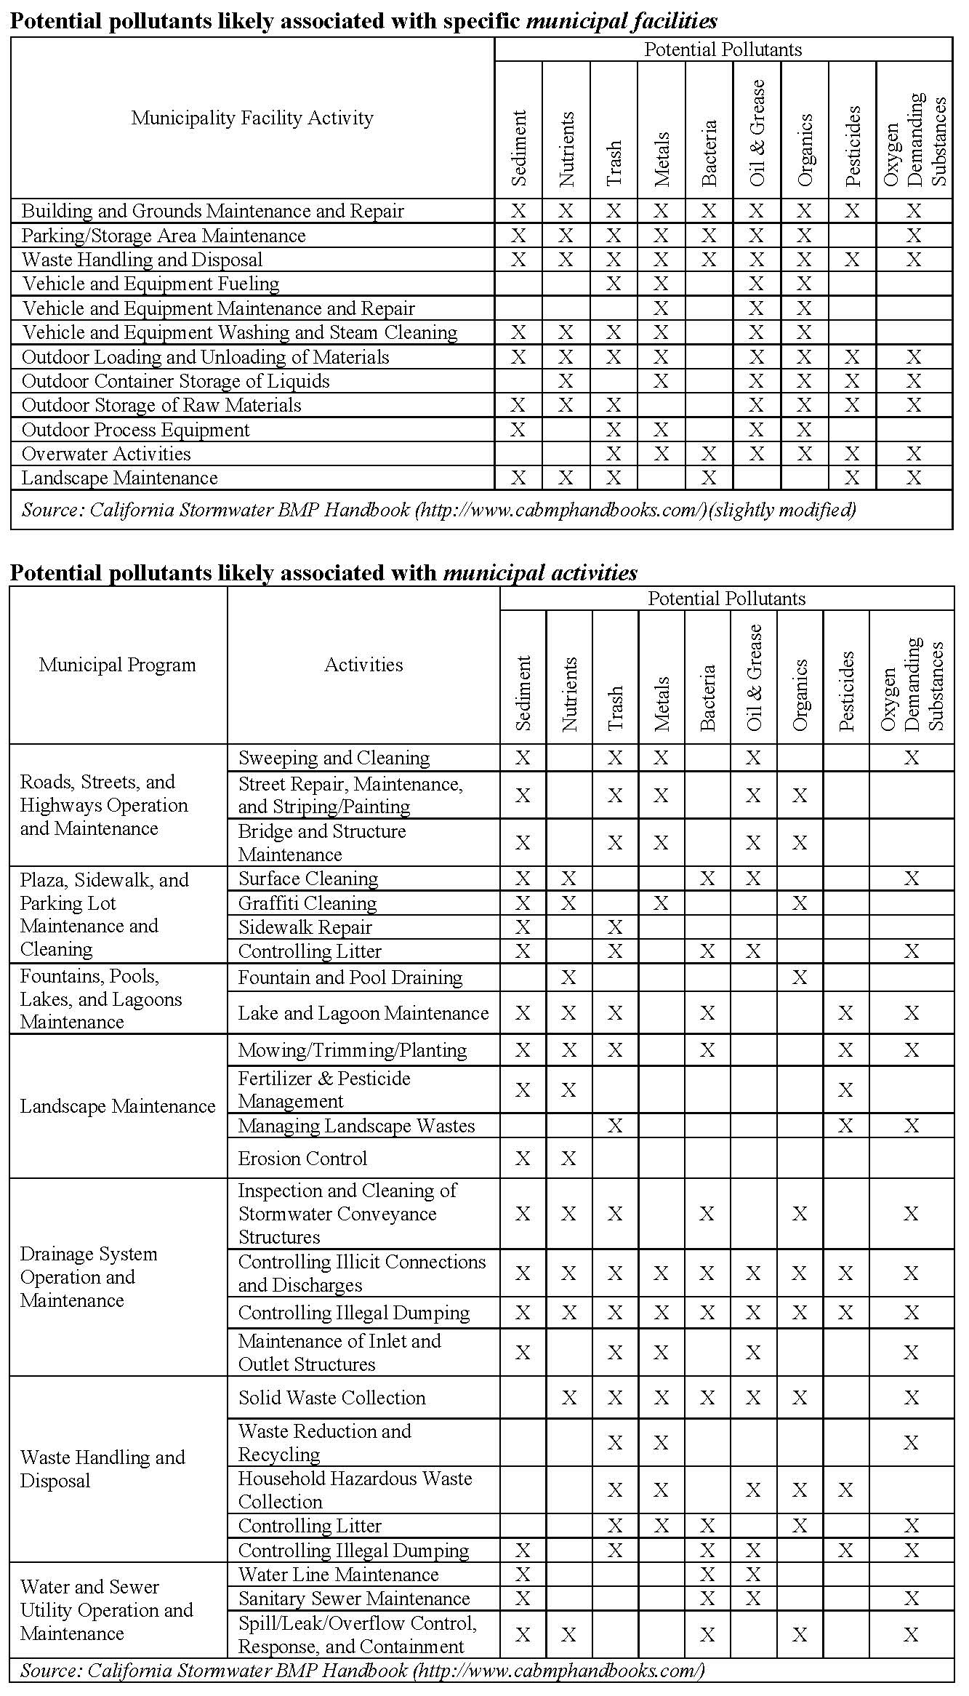
Source from EPA: http://epa.gov/npdes/pubs/potmunpoll.pdf

