

Penn State
BRANDYWINE
AT A GLANCE

14
baccalaureate programs you
can complete here

30+
clubs and organizations

12
varsity athletic teams

72%
of students receive
financial aid

Schreyer & Cooper

honors programs
Faculty-led

research opportunities
Internships Study-abroad
opportunities

275+
majors available in
Penn State’s
2+2 program
Located in

Media, PA
20 miles west of Center City Philadelphia


WELCOME

How will your story begin?
You have great possibilities. The way your story unfolds is up to you. We’re here to help you explore the Penn State degree that matches your life, expectations, and aspirations.

Discovery is what college is all about. It’s a time when you’ll find your passion for a career and make lifelong friends. At Penn State Brandywine, you’ll experience a vibrant college environment

combined with the resources of a major research university — all located just west of Philadelphia.

As you earn a nationally recognized degree in the beautiful suburbs, you can get involved in student organizations and athletics, make friends in a diverse environment, and gain valuable real-world experience through internships and networking opportunities.

ACADEMICS
SAVE ON TUITION BY STARTING YOUR PENN STATE DEGREE AT BRANDYWINE

Start Here, Finish Here

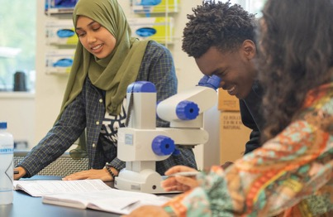
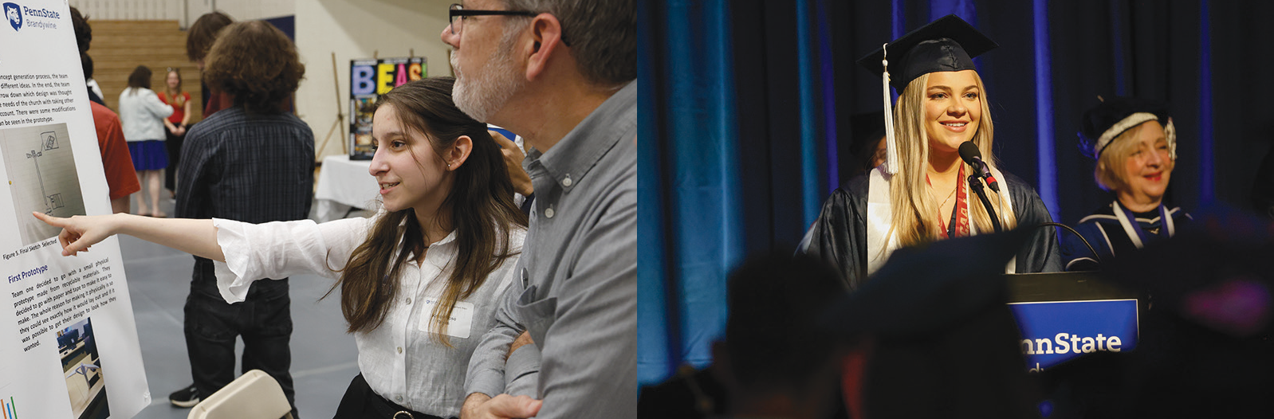
BACCALAUREATE DEGREES
American Studies Biology
Business
Communication Arts and Sciences Communications
Computer Science
Cybersecurity Analytics and Operations Engineering
English
Human Development and Family Studies Information Technology
Multidisciplinary Studies
Project and Supply Chain Management Psychology (B.A./B.S.)

ASSOCIATE DEGREES
Business Administration
Human Development and Family Studies Multidisciplinary Studies

ACADEMIC MINORS
Penn State Brandywine offers 18 minors ranging from civic and community engagement to environmental inquiry to global and international studies.

ACADEMIC OPPORTUNITIES
Honors Programs Global Programs
Undergraduate Research Internships

275+ MAJORS IN THE 2+2 PLAN
The 2+2 Plan allows students to complete the first two years of their degree plan at Penn State Brandywine and finish their program at University Park or any other Penn State campus that offers their specific major.

NO MAJOR? NO PROBLEM!
Many students are undecided about their major when starting college. At Penn State Brandywine, no major is no problem. In your first two years of coursework, you will explore a wide variety of subjects that work toward any number of degrees. This is a time for discovery. A time to find a major that is right for you.

Once you identify a major that you are passionate about, our faculty and staff advisers will help to set you on a course for future success in and out of the classroom.

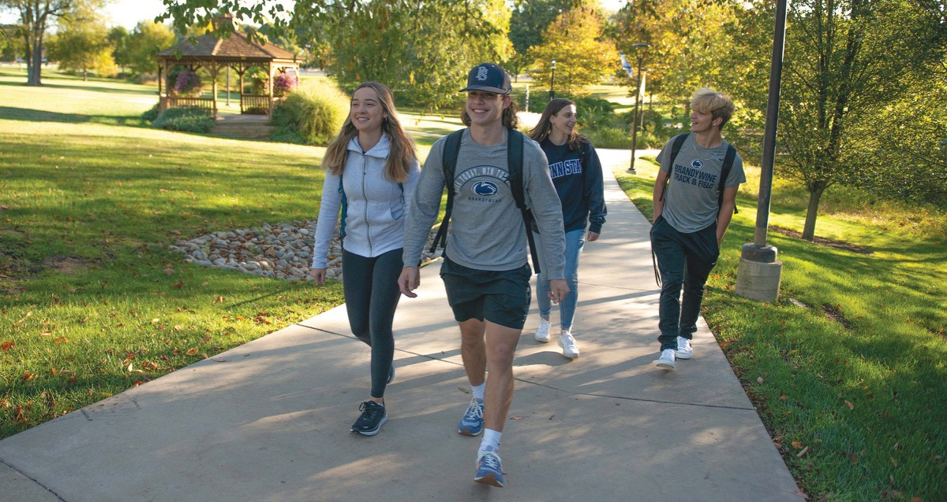
FINANCIALS

TUITION AND EXPENSES
A Penn State education is an investment in your future. Our tuition and housing rates are competitive with other public universities.

SCHOLARSHIPS AND FINANCIAL AID
At Penn State Brandywine, student scholars are valued and rewarded. In addition to scholarships awarded centrally by the University, Penn State Brandywine has more than 100 endowed scholarships offered each year through the generosity of our donors. All students are automatically reviewed for merit-based scholarships. We recommend students file a FAFSA to maximize financial aid award opportunities.

Our Admissions and Financial Aid staff are here to help put a Penn State education within the reach of every student and they can help you identify and
apply for a variety of grants, loans, work-study, campus employment, and scholarships.

Learn more about tuition and fees, financial aid, scholarships, and work study at:
brandywine.psu.edu/tuition-financial-aid

OVER 72% OF OUR STUDENTS
RECEIVE FINANCIAL ASSISTANCE

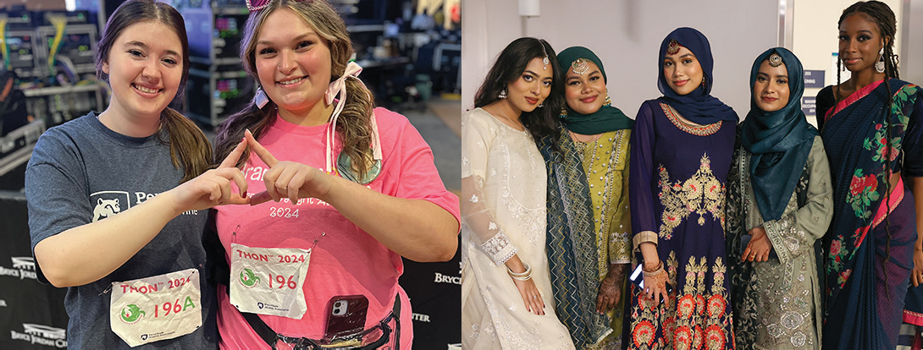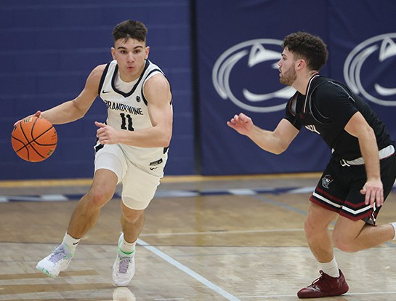

EXTRACURRICULAR

ATHLETICS (NCAA DIVISION III, UNITED EAST CONFERENCE)
Student-athletes compete in 12 men’s and women’s varsity sports. All students have use of athletic facilities, including the fitness center and outdoor sports court.

VARSITY SPORTS
STUDENT CLUBS
Penn State Brandywine students can choose from a variety of clubs and organizations that meet their
interests and career goals, including academic, honors, service, leadership, and special interest.


Men’s Baseball Basketball Cross Country Golf
PROVISIONAL MEMBER OF
NCAA DIVISION III
Soccer Tennis
Women’s Basketball Cross Country Soccer Softball Tennis Volleyball
Popular clubs include Anime Club, Brandywine Events

and Activities Support
Team, Black Student Union, Brandywine Benefitting
THON, Brandywine
Leagues and Tournaments, Dungeons & Dragons, and Multicultural Club.

CAMPUS LIFE

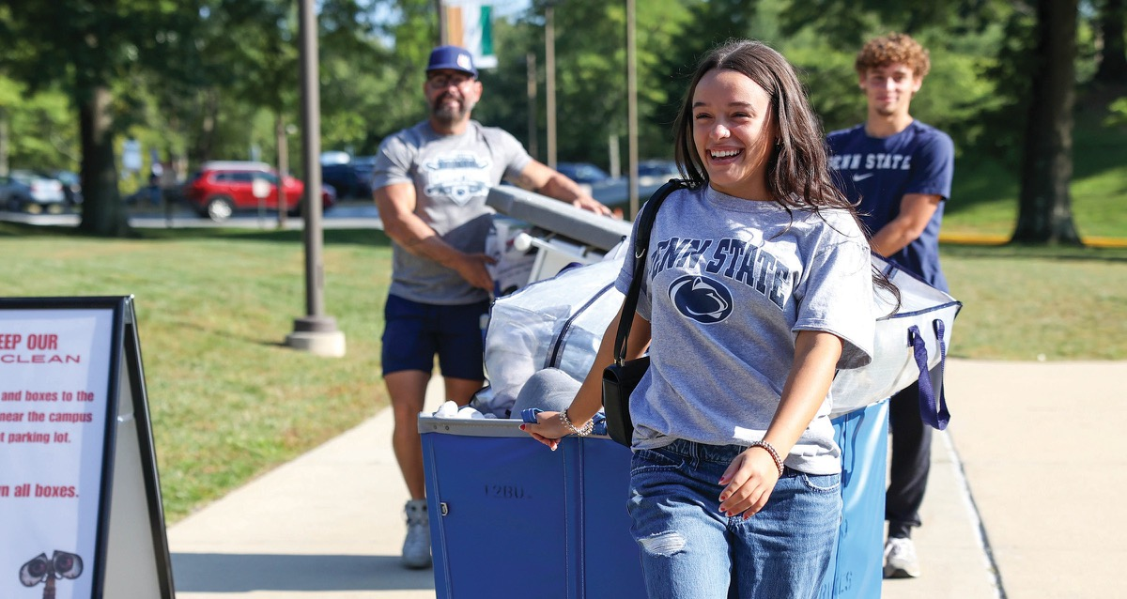
HOUSING
Orchard Hall features a living environment that is conducive to learning while providing a social
setting where students can engage with their peers. Professional live-in staff and resident assistants provide support services as well as a schedule of group activities that enhance the collegiate experience.

Features include:
- High-speed Internet connections and WiFi
- Microwave/refrigerator unit
- Laundry facilities
- Secure access with ID Card
- On-campus parking
- Full-service campus police department

BLUE APPLE CAFÉ
The Blue Apple Café is located in the Student Union. The Café is open seven days a week during the academic year and features soups, subs, daily entrees, salad bar, grab-n-go items, and a coffee bar featuring Starbucks coffee. We also offer half gallons and pints of Penn State Creamery ice cream!

MORE THAN 250 STUDENTS LIVE ON CAMPUS IN ORCHARD HALL


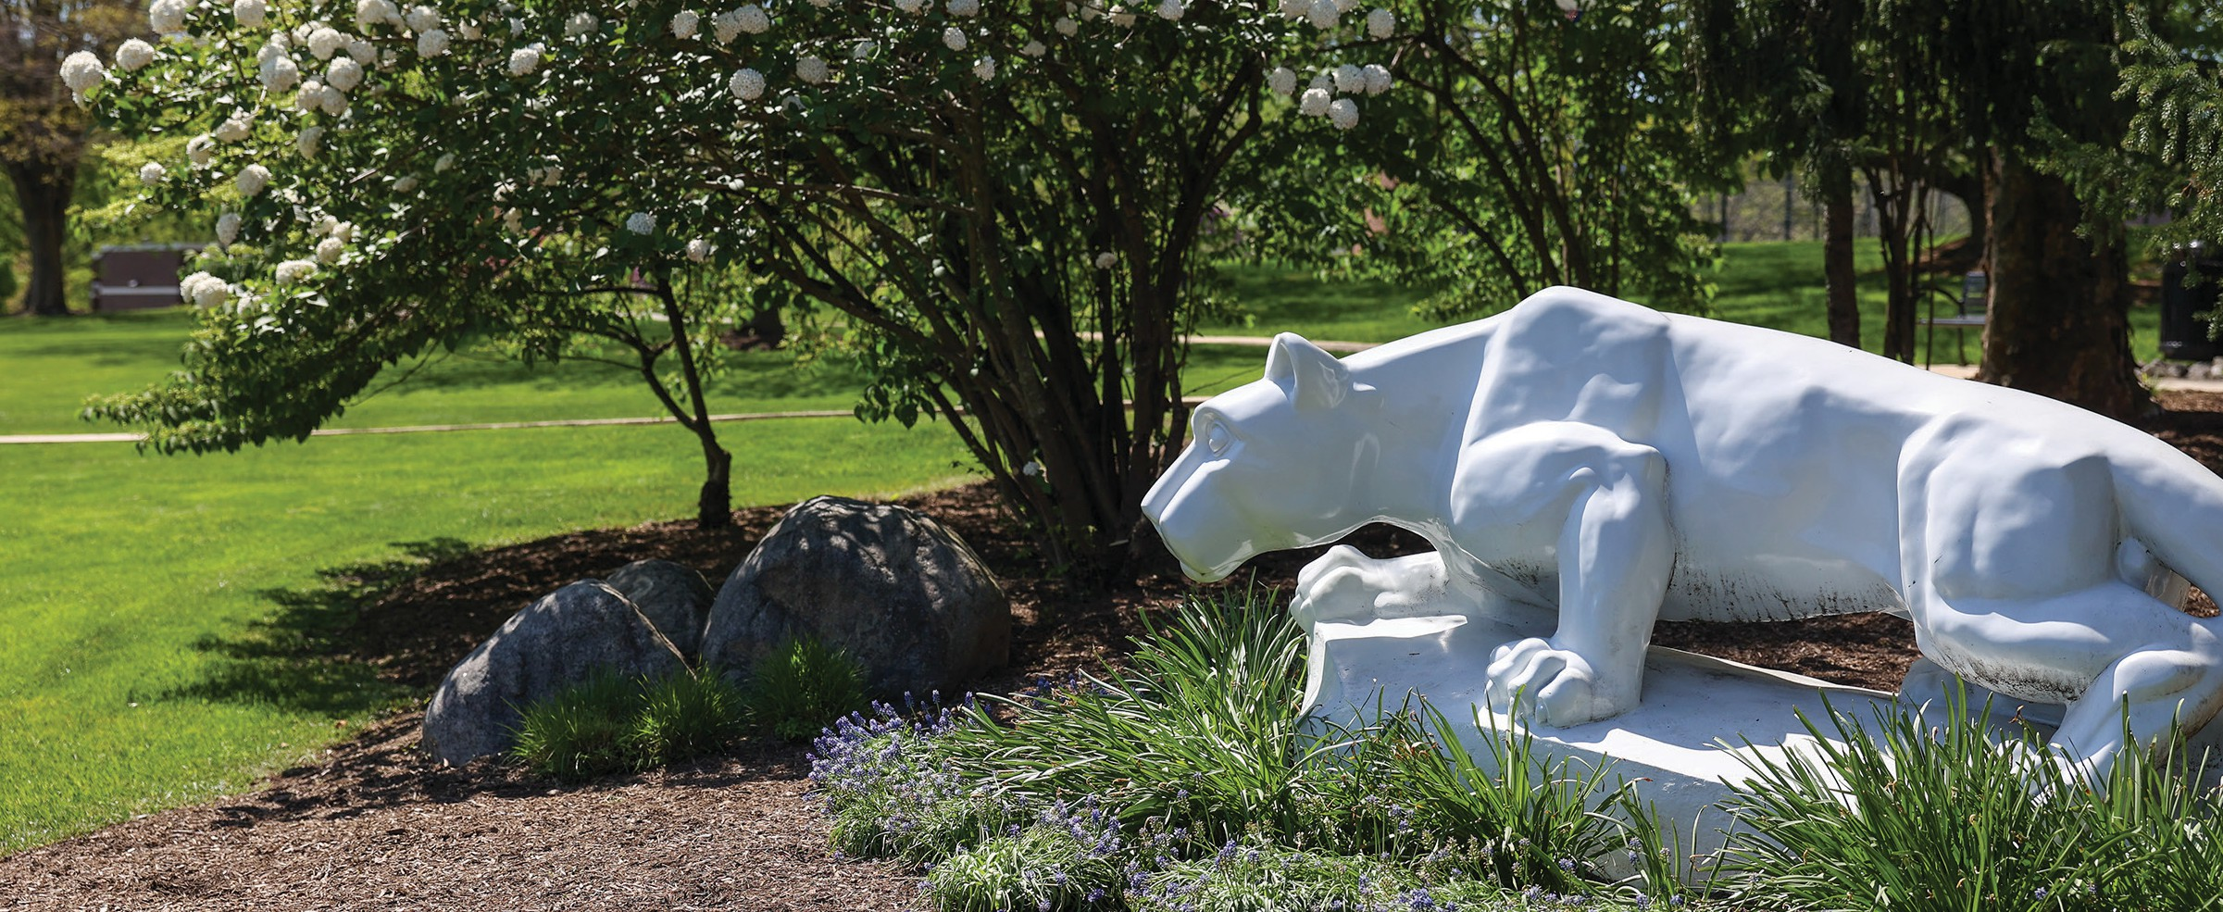
We Are
Penn State

This publication is available in alternative media on request. Penn State is an equal opportunity, affirmative action employer, and is committed to providing employment opportunities to all qualified applicants without regard to race, color, religion, age, sex, sexual orientation, gender identity, national origin, disability or protected veteran status. UBR BWO 24 -75

Contact us
Penn State Brandywine Office of Admissions 25 Yearsley Mill Road Media, PA 19063
610-892-1225
bwadmissions@psu.edu

Learn more
brandywine.psu.edu

Connect with us
FACEBOOK: /PennStateBrandywine INSTAGRAM: @psubrandywine LINKEDIN: PennStateBrandywine TIKTOK: @pennstatebrandywine

